Committee Meeting
4th June 2019 at 7.00pm

Venue:Berkeley Pigeon Club
Present: J Sheppard, D Armstrong, D Miller, A Zahra, D Louth, M Maidman, Andrew Szalai
Peter Clark

Minutes of Previous committee meeting:
Moved: D.L Second: M.M

Treasurer report: All in Favor

correspondence: Received:

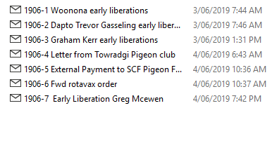
General Business

1: The long distance committee would like to start tossing for two weeks after the long weekend with the Fed trailer on the 16th June from Woronora on Sundays that’s if they can get enough support,it will be 25cents a bird the trailer will hold about 700 birds. The basket points will start at Shellies, Berkeley,Woonona
The liberation will be at 1.00pm.

2: You need to be a full flying member to vote on any flying matters in the SCF.
Moved:D.M second: M.M

3: Open 700 mile race from Yunta (SA) basket at Dapto pigeon club-Tuesday 3rd September
Time to be decided on.
It will be $10.00 a pigeon there is no limit entry’s need to be in two weeks before basket night
1st Sawtell Pat Arcella will donate Dickens Medal 1st Gold 2nd Silver 3rd Bronze

4: The long distance committee will hold a raffle and pigeon auction
on Towradgi premiere stakes night.

5: The East Coast Classic will be different this year there will be a overall prize and section prize’s
basket birds and read your clocks at your own club.
$5 per bird 5/bird limit.

Next meeting will be at Shellies Pigeon club
2nd July 2019 at 7.00pm

meeting closed 8.40pm

